**School of Computing**

|  |  |
| --- | --- |
| Module Title and Code | BUSINESS INTELLIGENCE - M33150 - FHEQ 7 |
| Module Coordinator  Other lecturers | Dr Elisavet Andrikopoulou  elisavet.andrikopoulou@port.ac.uk |
| Assessment Item number | ref/def coursework |
| Assessment Title | Happy phones case study |
| Date Issued | 2024-06-24 |

**Schedule and Deliverables**

|  |  |  |  |  |
| --- | --- | --- | --- | --- |
| Deliverable | Value | Format | Deadline / Date | Late deadline  ECF deadline |
| Solution to case study | 100% | One PDF File. Individual submission. | 2024-07-26 16:00 [GMT/BST] | N/A |

**Notes and Advice**

* The [Extenuating Circumstances procedure](https://myport.port.ac.uk/my-course/extenuating-circumstances) is there to support you if you have had any circumstances (problems) that have been serious or significant enough to prevent you from attending, completing or submitting an assessment on time. If you complete an Extenuating Circumstances Form (ECF) for this assessment, it is important that you use the correct module code, item number and deadline (not the late deadline) given above.
* [ASDAC](http://www2.port.ac.uk/additional-support-and-disability-advice-centre/) are available to any students who disclose a disability or require additional support for their academic studies with a good set of resources on the [ASDAC moodle site](https://moodle.port.ac.uk/course/view.php?id=3012)
* The University takes any form of academic misconduct (such as plagiarism or cheating) seriously, so please make sure your work is your own. Please ensure you adhere to our [*Student Conduct Policy*](https://policies.docstore.port.ac.uk/policy-261.pdf) and watch the video on [Plagiarism.](https://www.youtube.com/watch?v=2a0QJnCmfEs)
* Any material included in your coursework should be fully cited and referenced in **APA 7** format. Detailed advice on referencing is available from the [library](https://library.port.ac.uk/w165.html), also see [TECFAC 08 Plagiarism](https://www.youtube.com/watch?v=2a0QJnCmfEs) and <https://library.port.ac.uk/referencing>.
* Any material submitted that does not meet format or submission guidelines, or falls outside of the submission deadline could be subject to a cap on your overall result or disqualification entirely.
* If you need additional assistance, you can ask your personal tutor, student engagement officer [ana.baker@port.ac.uk](mailto:ana.baker@port.ac.uk), academic tutor [eleni.noussi@port.ac.uk](mailto:eleni.noussi@port.ac.uk) or your lecturers.
* If you are concerned about your mental well-being, please contact our [Well-being service](https://myport.port.ac.uk/guidance-and-support/health-and-wellbeing)

## **Overview – Happyphones LTD**

Happyphone LTD is a limited company, delivering mobile communications services in the UK. Happyphone LTD has approximately 53 retail stores, and services more than 1 million connections across its mobile network.

Happyphone LTD is currently using an outdated customer service system and they are looking to improve it.

In the current system, when a customer calls the helpline, they have 3 choices, either to go to sales or to connections or to “other”. This is not very efficient and does not cover the workload of the company, since its growth. When a customer selects an option then they may wait up to 2 hours to be connected with a representative.

The representative, based on their expertise, may or may not be able to answer the customer’s inquiry.

The top 3 queries the Happyphone LTD are getting from their customers are:

1. Lost/stolen phone inquiries

2. Bill inquiries

3. Connectivity issues

If the customer is not satisfied with the response or if the representative is unable to answer, then the customer’s query is escalated and the customer is connected to the second line of customer service, which deals with more complicated queries.

After the escalation takes place, if the customer is happy then the query is resolved or if there are still issues, the customer is then connected to the daily customer services manager. Happyphone LTD has two customer service managers, who alternate their customer service problem solving duties daily. At that stage, the manager must solve the problem, one way or another.

They are looking to identify problems around customer support and knowledge base management.

You have been assigned to delve into their data mart and identify potential trends and problems.

**To access the star schema and the data:**

1. Connect to the university’s VPN.

2. Go to Azure data studio, connect with your login details as we did in the workshop and are detailed on Moodle.

3. Select the HappyPhones database. You are **NOT** allowed to use any other data warehouse.

You are provided with the following star schema.

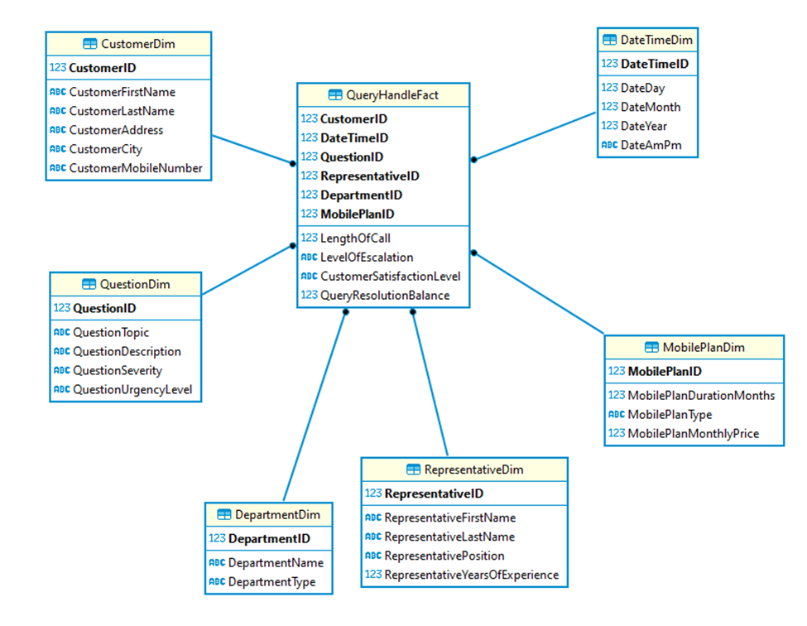

You have been given the following tasks:

# **Task 1**

Write and run **3 SQL queries**. You must submit a screenshot of the queries running and its results as well as the short description of the business rationale in no more than 100 words per query.

*Notes:*

· Your queries must be meaningful and demonstrate the strength of DW in supporting decision makers.

· Your queries must use a broad range of fact tables and dimensions of the provided DW.

· You should provide a short description of each query, to explain the business rationale for creating it.

· All 5 queries must be different from each other, using different fact tables and dimensions.

· All 5 queries should include at least one data warehouse concept. Queries such as “select * from tablename where simple condition” and repetitive queries, will get marked as zero.

{Total marks: 30}

# **Task 2**

Modify the given schema and suggest at least 1 more dimension that would provide you with insights that you wish there were there.

Hint: It is common knowledge in the company that the extent of the knowledge base is underutilised and underrepresented in the data warehouse.

Submit the dimension in the form of a table.

For the dimension:

· Provide reasoning and rationale for your choice (also known as: why this dimension and how can we use it?)

· You need to submit it, following the same naming convention that exists in the data warehouse.

· The dimension should seamlessly blend together with at least either the fact table or one dimension of the current schema.

{Total marks 20}

# **Task 3**

**You are instructed to create a dashboard with 3 visualizations.**

All the data on these 3 visualizations must come from the HappyPhones data warehouse and you must decide, which 3 visualizations you will create and why. You are allowed to visualise your queries from task 1.

· You must use Tableau or Flourish to create your dashboard.

· You can create more than 3 visualizations, but they will not get extra marks.

You are given full freedom as to what and how you will use your data to visualise but you have to justify your decisions and explain their relevance to business. Therefore, you must submit a good quality picture of the dashboard, which needs to be readable and a short report (use no more than 500 words) explaining at least:

Hint: Use the four stages of the data visualization design process as discussed in lectures

1. Your design decisions (including aesthetics) regarding your visualisations and dashboard.

2. You must discuss how your dashboard blends together and how the visualisations promote understanding of the business rationale.

# **Task 4**

**Quiz - Select the correct answer(s) for each of the following questions**

Q1

What risks do business people face with respect to expertise and experience while introducing new BI technologies and analytical techniques?

(select 1 correct answer)

a. Organizations will not have the expertise in the new concepts and techniques to effectively use the new tools

b. Business people will know how to leverage the new BI technologies and analytics to obtain business value.

c. Both

d. None

{marks 2}

Q2

When defining data quality requirements, you should keep in mind that:

(select 1 correct answer)

a. Source system data is always excellent

b. Data quality problems are often caused by conflicting data silos

c. Data cleansing tools will fix any data quality problems

d. The most common cause of data quality problems is sloppy data entry

{marks 2}

Q3

When designing a BI application, what is more important?

(select 1 correct answer)

a. Elegant design

b. Cool fonts

c. Consistent templates

d. Eye-catching graphics

{marks 2}

Q4

Which of the following is true:

(select 1 correct answer)

a. Once created, the data marts will keep on being updated from the data warehouse at periodic times

b. Once created, the data marts will directly receive their new data from the operational databases

c. The data marts are different groups of tables in the data warehouse

d. A data mart becomes a data warehouse when it reaches a critical size

{marks 2}

Q5

Use storyboards to:

(select 3 correct answers)

a. Work out the visual details of multimedia items

b. Determine how the business person will interact with the application

c. Understand how different analyses are related

d. Create the workflow between different analyses

{marks 2}

Q6

What is most important when it comes to data visualization?

(select 1 correct answer)

a. The use of dashboards

b. Flashy visuals that catch the users’ eyes

c. Enhancing user understanding

d. Using multimedia in the presentation of data

{marks 2}

**You must submit 1 pdf document** including the answers to all 4 tasks.

Marking scheme

|  |  |  |  |  |  |
| --- | --- | --- | --- | --- | --- |
| Marks | Task | Fail (<40%) | Pass (40-59%) | Good Pass (60-69%) | Excellent (70% +) |
| Criteria for all tasks | | Inadequate UK English  grammar and spelling.  Does not follow  submission  instructions | Mostly correct UK English  grammar and spelling.  Complies with most  submission instructions. | Correct UK English grammar and  spelling with clear writing style  and a good presentation. Complies  with all submission instructions. | Correct UK English grammar and spelling.  Clear writing style with excellent  structure and presentation. Complies  with all  submission instructions |
| Task 1  {total of 3 x 10 = 30 marks} | | | | | |
| 5 (per query) | Correctness of query | Deficient/ wrong query | Functional query not based on data warehouse principles | Mostly Good but lacks completeness / a few problems | Complete, relevant, query correct |
| 5 (per query | Logic of query | Deficient/ lucks logic | Very simplistic but still functional | Mostly good but less business logical / less useful | Very good business logic, at the right level |
| Task 2  {Total 20 marks} | | | | | |
| 20 | Dimension (correctness & logic) | Deficient/ wrong dimension & logic | Dimension correct, blends together but without sound rationale or data dictionary. | Dimension correct, blends together, data dictionary present and correct but without sound business rationale or business rationale present but not useful for such a company. | Dimension correct, blends together, data dictionary present and correct. Business rationale present and useful for such a company. |
| Task 3  {Total of 34 marks} | | | | | |
| 19 | Dashboard design and report evidence | No serious attempt, completely wrong or only minimal understanding. | Adequate design, with minimal satisfactory explanation of the connection between the selected visualisations and insights.  There is evidence that the student has engaged with the content, but some understanding is lacking. | Sound design and rationale with good critical appraisal of the selected visualisations and insights.  There is evidence that the student has engaged with the content and understands most of it. | Great design, convincingly argued rationale with excellent critical appraisal of the selected visualisations and insights.  The student has an excellent understanding of the data visualisation practise and has applied it accurately. |
| 5 (per viz) | Visualisation | No serious attempt, completely wrong or only minimal effort. | Adequate design, with minimal satisfactory explanation of the visualisation, or simply reading the data. | Sound design and rationale with some explanation of visualisation. Student modified Tableau or Flourish defaults. | Great design, convincingly argued rationale with great explanation of visualisation. |